The short codes document is only all the short codes in the emails. I need a document of all the possible short codes. If I want to send an email to the user with the customers name and not username for example, I cannot do it. I also need the ability to paste picture in email. More color does not work 🡺 Done

This is not US date format. Is this necessary to be this way? ==== Done by mm-dd-yyyy

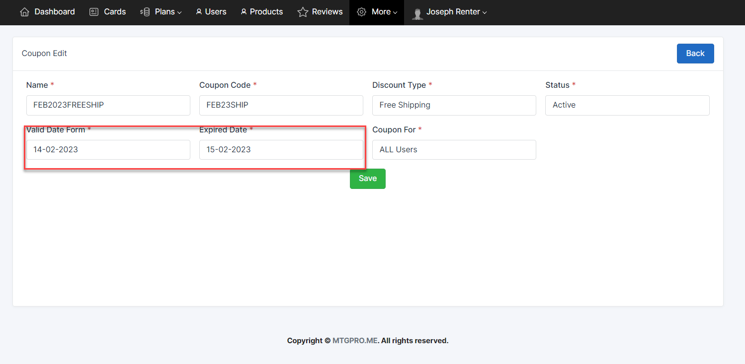

How do I control where the pages are? Why do only some say footer? 🡺 it was wrong plan for the first time , now it romoved.

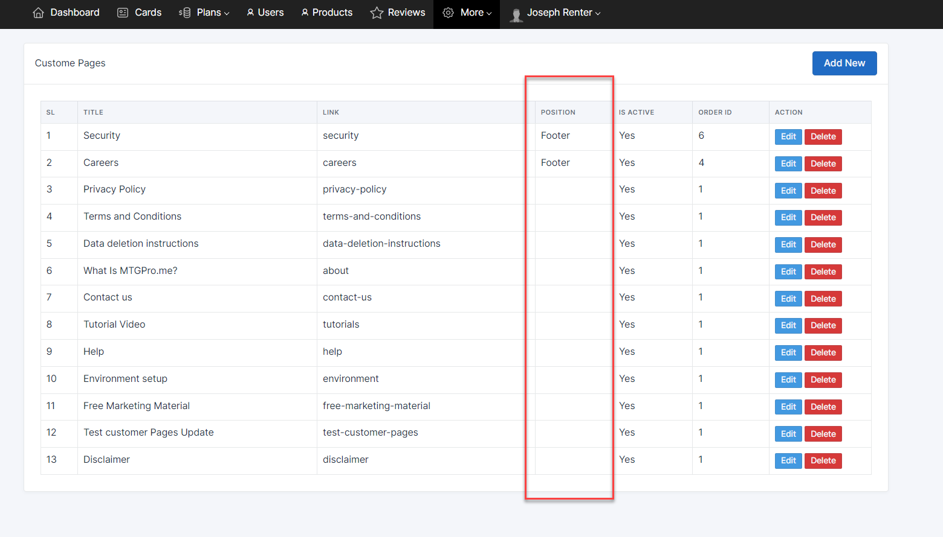

It is working for me .

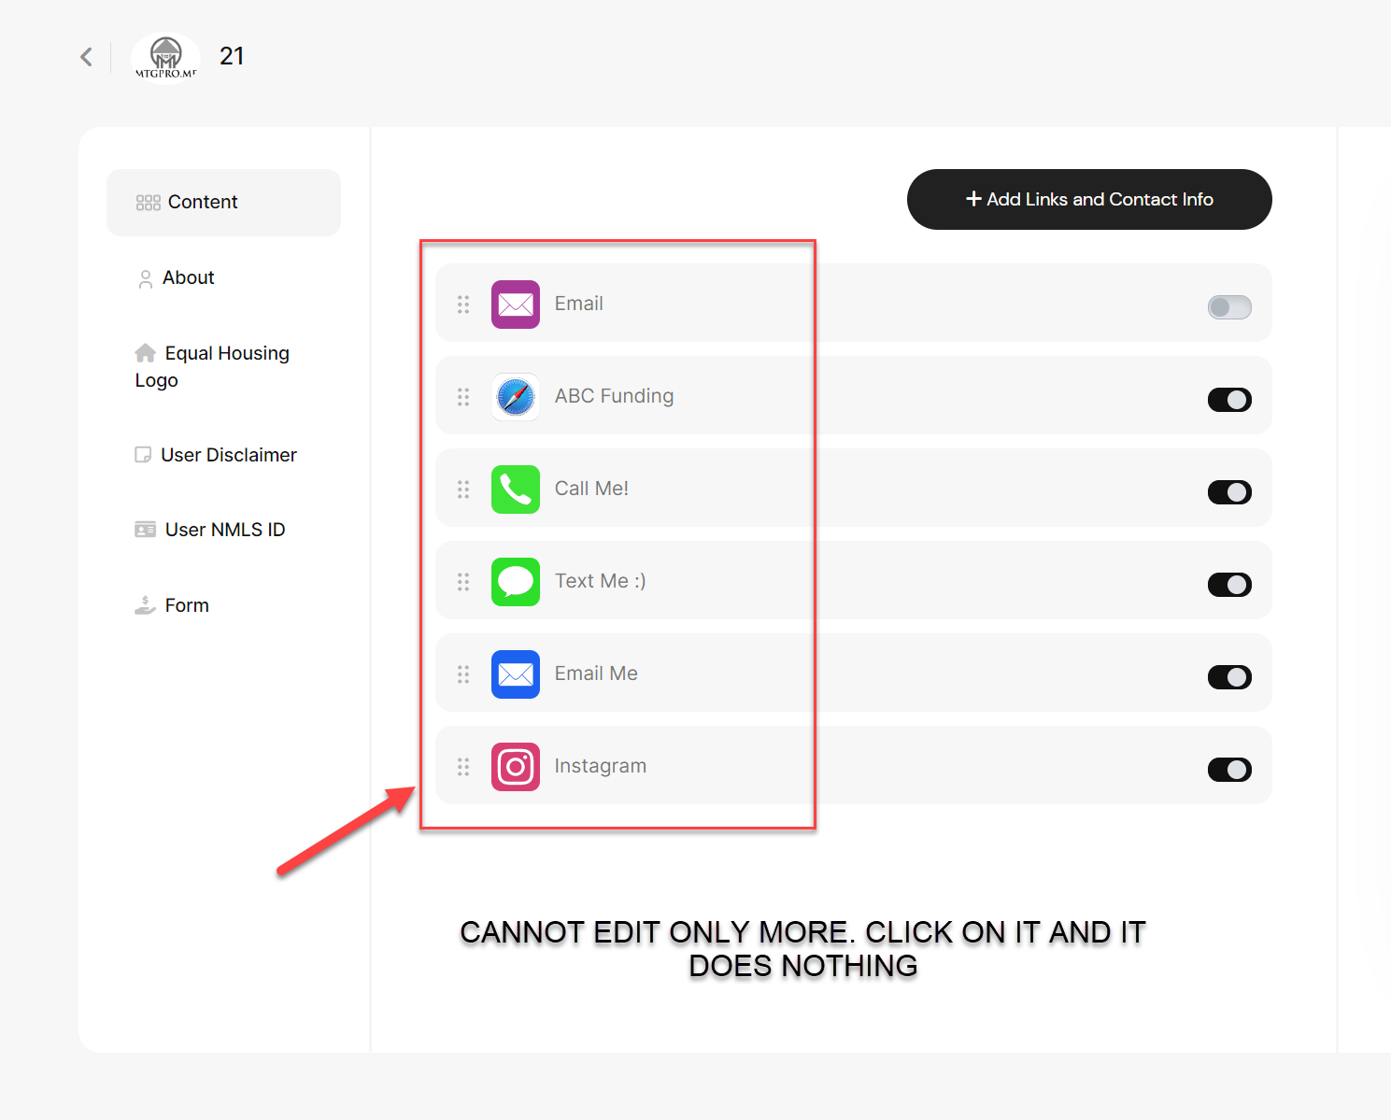

2- preview of live card and what is seen in view card do not match. This is an issue. Both need to display what the read card will show. 🡺done

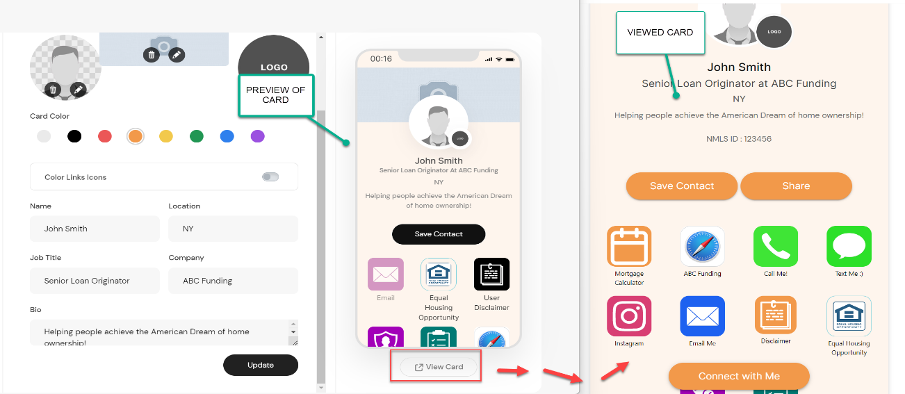

3 – Color schemes not following all of icons 🡺 DONE

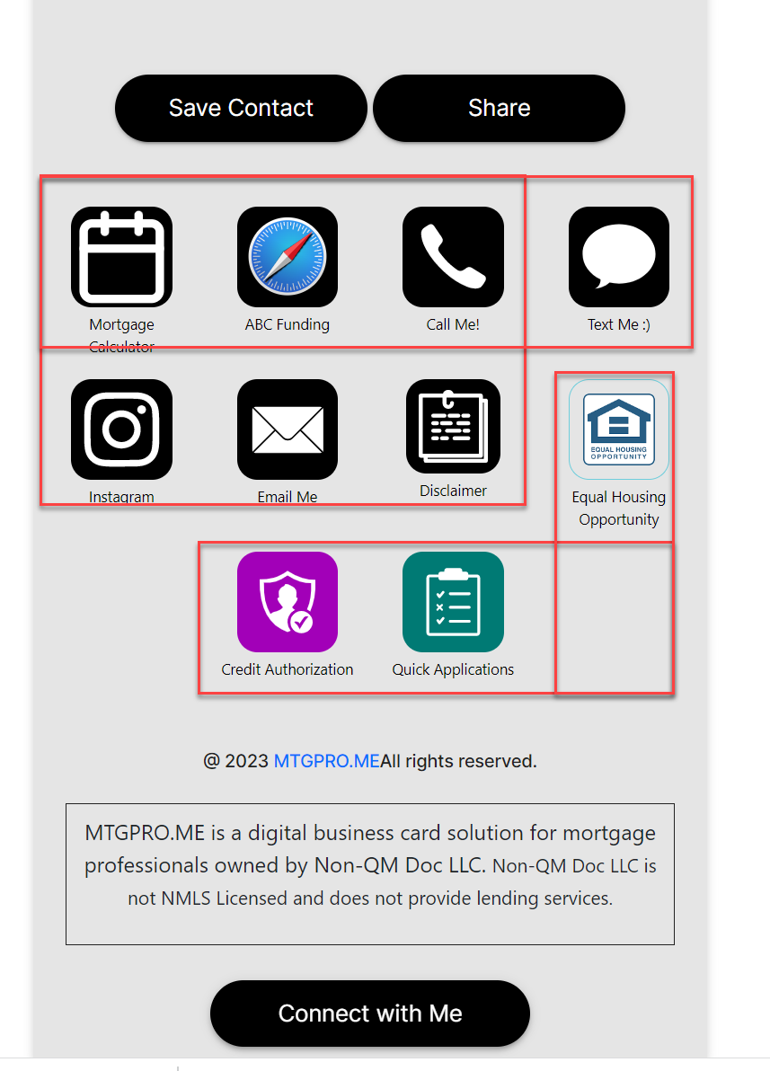

4 – the Grammar is incorrect here. It should ready: 🡺 You can change this from admin panel , More -> General Settings -> Site Disclimer

Do you have a suggest for a new feature? Let us know how! 🡺done

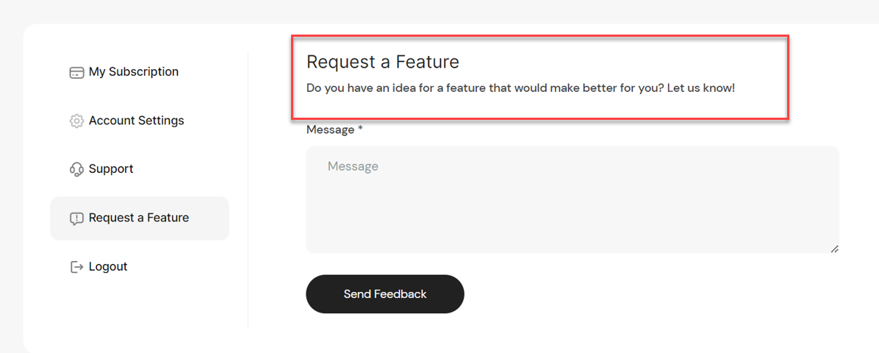

5 - How can I give people free accounts with all the tools and benefits? 🡺 Done

6 – insights and CRM aren’t synced still and when a contact is made, the auto response to the visitor and ccing the user is not happening. When user clicks to email lead, it doesn’t send or doesn’t cc the user.

If the app is coming we could remove the email lead with smtp email and just open email app.

7 – why are all my product images gone? 🡺 need to check on server

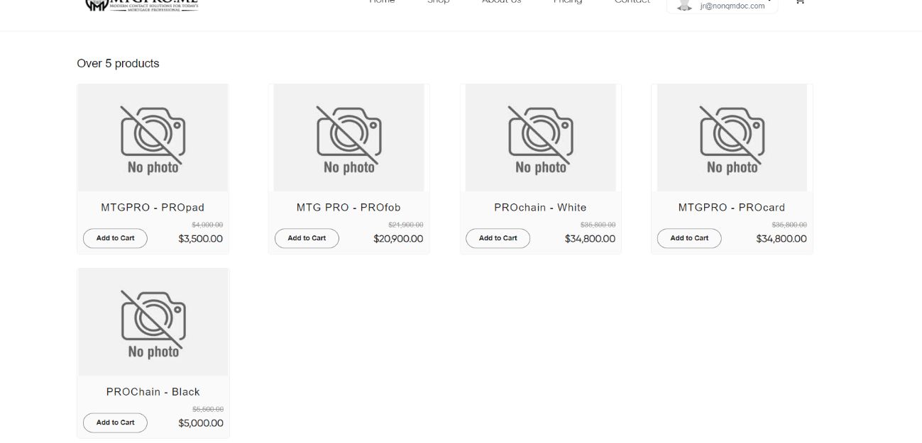

8 – many of these do not work in various places. 🡺 We need to know where it is ?

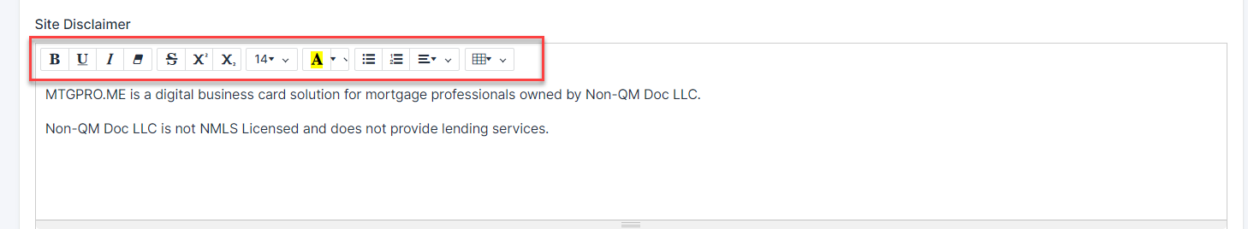

9 – what are these credentials? 🡺 mail server

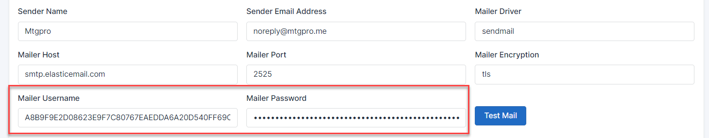

10 - don’t I need my own of these? 🡺 Yes Need to change by yours.

